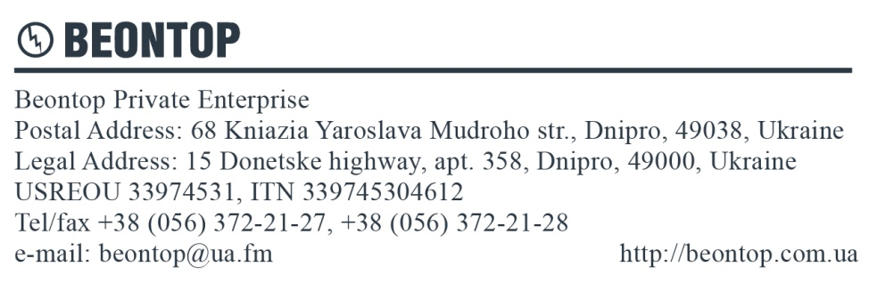

Questionnaire
for ordering current transformers
Company name:
Contact person:
Telephone Fax E-mail

Parameter name | Parameter value
Type of transformer (underline) | TOLU-10-1, TOLU-10-2, TOLU-10-3, TOLU-10-4, TPLU-10-1, TPOLU-10-1, TPOLU -10-2, TPOLU -10-3, TCS1
Highest voltage for equipment, [kV]
Secondary winding number | №1 | №2 | №3 | №4
Rated primary current, [А]
Rated secondary current, [А]
Accuracy class
Rated burden, [VA]
Instrument security factor, FS
Accuracy limit factor, ALF
Rated short-time thermal current - 1 sec, [kA]
Rated dynamic current, [kA]
Climatic performance and category of placement
Quantity, pcs.
Desired shipping date
Notes:

Date:____________ Signature______________

